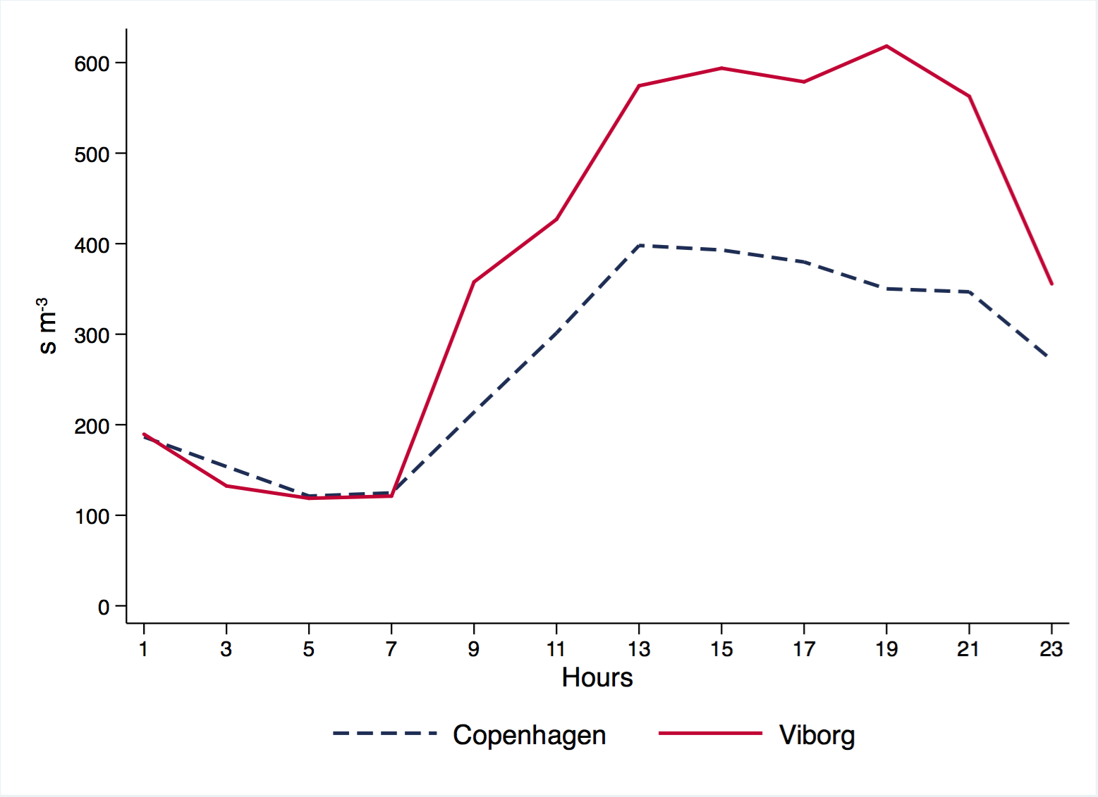
Hours | 01:00 | 03:00 | 05:00 | 07:00 | 09:00 | 11:00 | 13:00 | 15:00 | 17:00 | 19:00 | 21:00 | 23:00
Pvalue | 0.33 | 0.04 | 0.19 | 0.12 | 0.03 | 0.15 | 0.05 | 0.02 | 0.01 | 0.02 | 0.10 | 0.95

Fig. 3. Diurnal profile of Alternaria spp. concentration in Viborg and Copenhagen, based on the bi-hourly
concentrations average on the high days (with daily average ≥100 s m⁻³) and the p-value (bold when
the p-value <0.05) from the Wilcoxon rank-sum test, comparing the bi-hourly concentrations on the high days
between the Copenhagen and Viborg stations.

