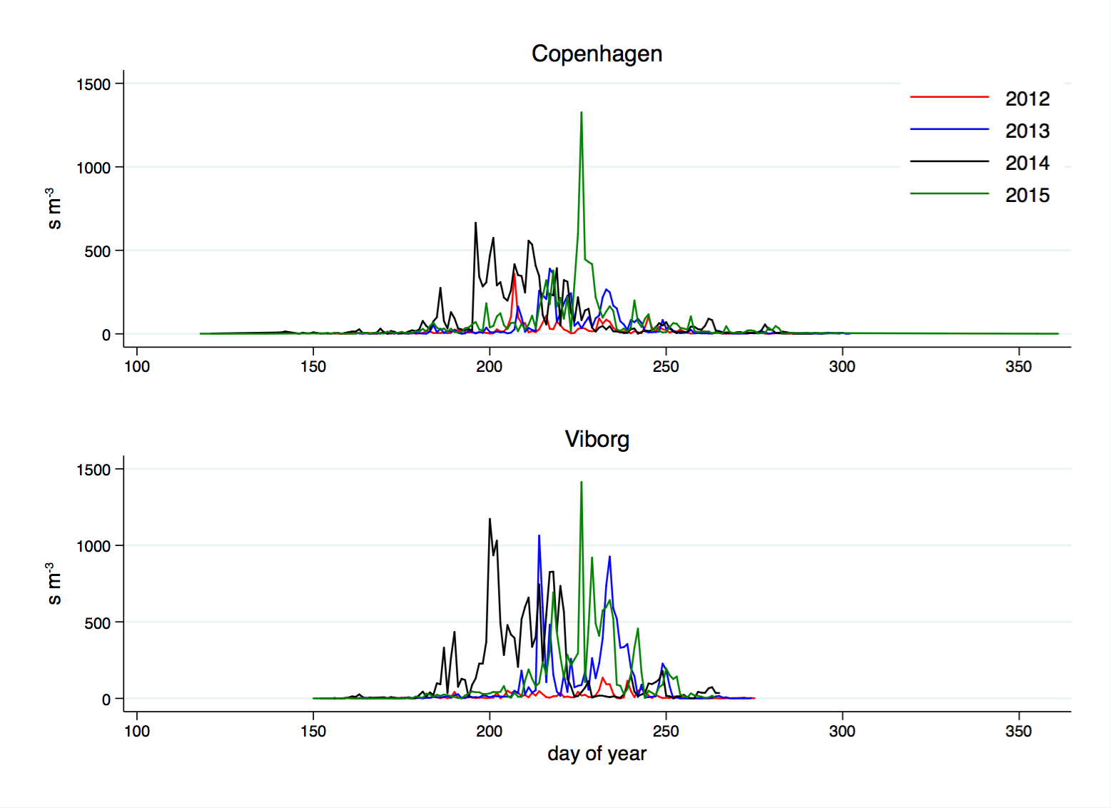
Fig. 2. Daily time-series of airborne Alternaria spp. at Copenhagen and Viborg stations (2012-2015).

