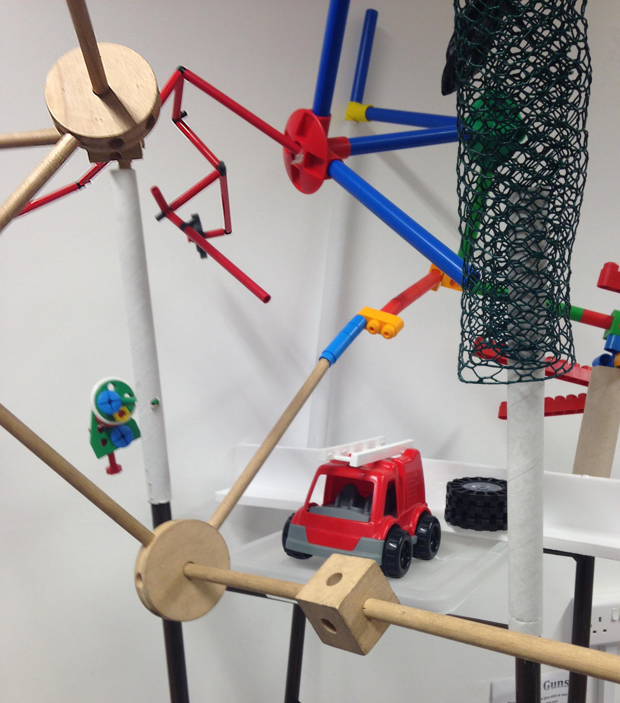

This 3-dimensional depiction of a conceptual canvas is an adaptation for research in education of elements of Cubist Art: rhizomatic combinations of ideas from conceived reality assembled as a radial model related to a broad based theme –

\*Experience: the conceptual canvas represents the process of burgeoning experience. The canvas is an external form of an ongoing contemplative relationship to data collected serendipitously. The canvas is therefore in a state of change

\*Metaphors: outcome space, criss-cross landscape, photo-montage

\*Aesthetics: conceptual aesthetics, personal aesthetic

\*Virtual landscape: evocative objects, satellite topics, creative analytic paradigm, generative social research.