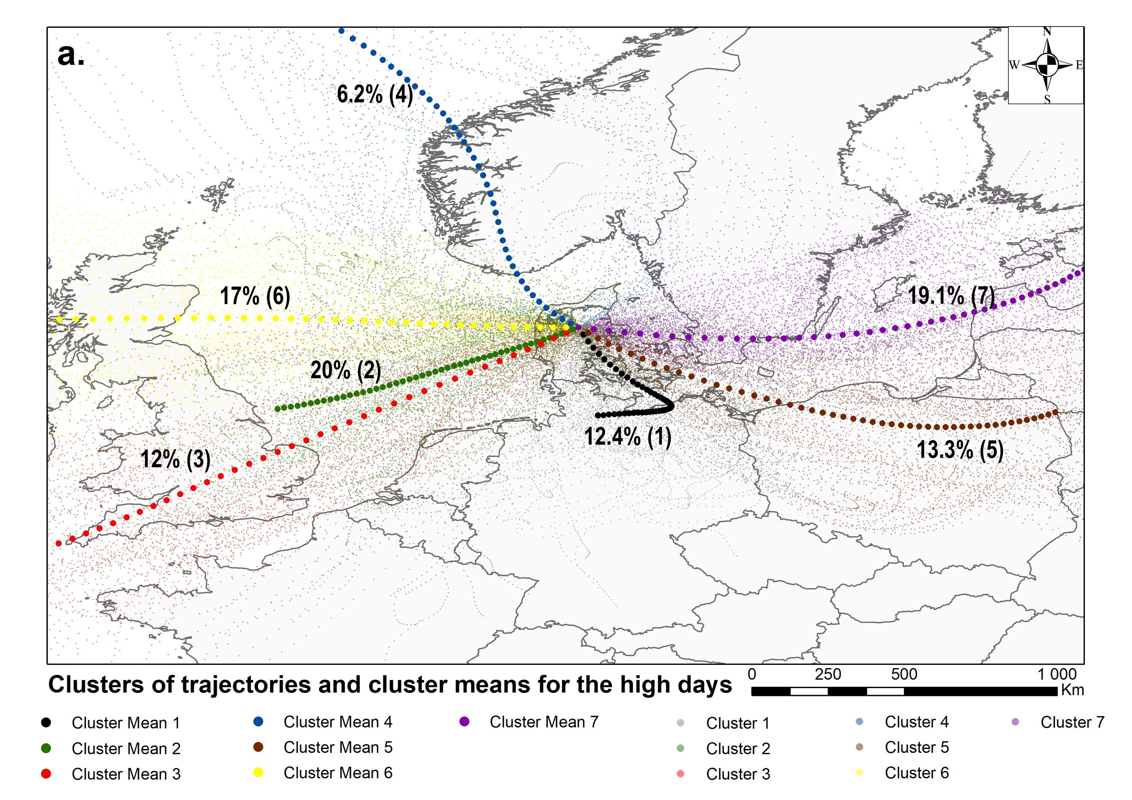 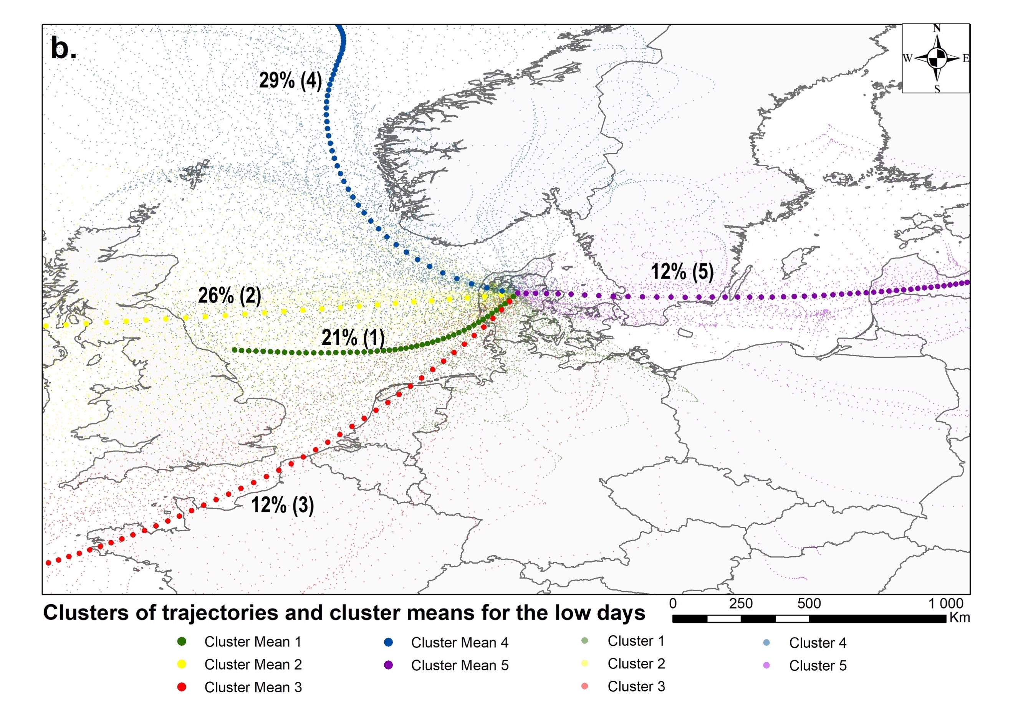Fig. 5 Clusters and cluster means of 48-h back trajectories for the Viborg station on the days with daily average concentration: a. ≥ 100 s m⁻³ (high days) and b. < 100 s m⁻³ (low days).

