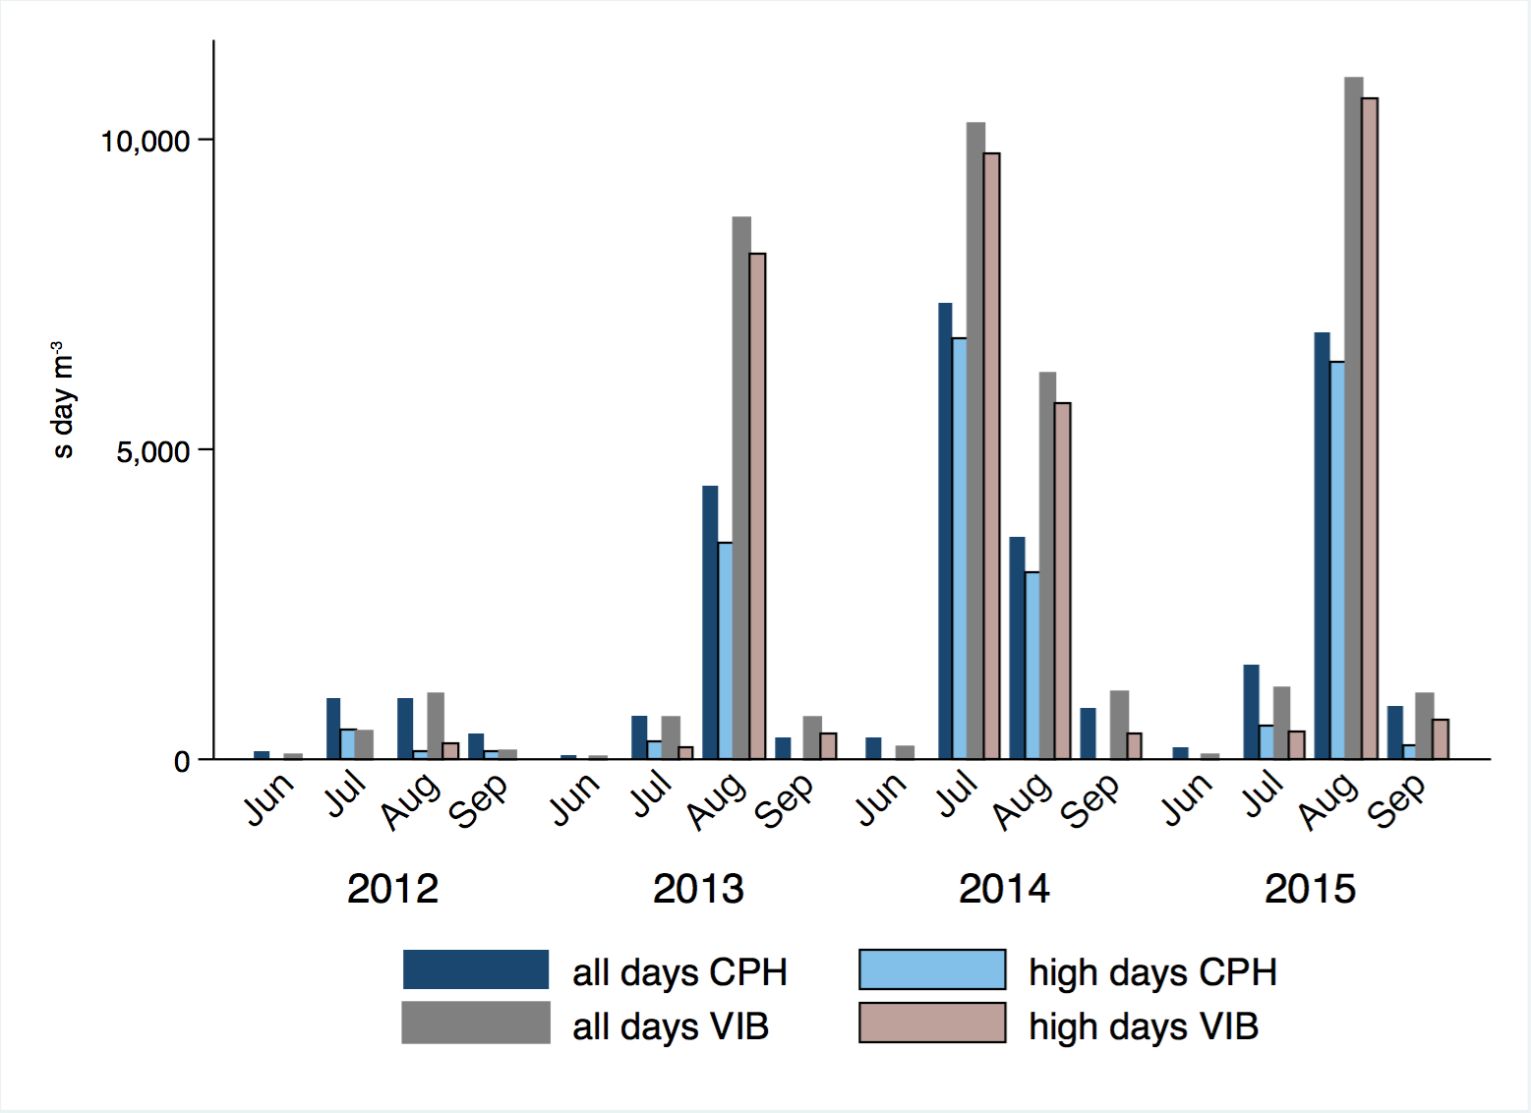

Fig. 1. Monthly spore integrals of airborne Alternaria spores (2012-2015) for all days and for high concentration days (with daily average concentration ≥100 s m⁻³); CPH – Copenhagen; VIB – Viborg.

