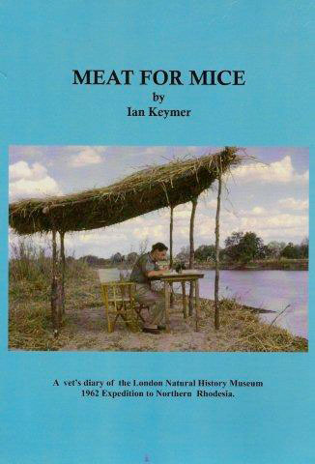
Meat for Mice – A vet’s diary of the London
Natural History Museum 1962 Expedition to
Northern Rhodesia
Ian Keymer
Romney Publications Ltd, £45.00
In 1962, Ian Keymer set out with
museum staff from the London
Natural History Museum for
Northern Rhodesia (now known as
Zambia) to collect specimens. As a
vet and pathologist, his main job was
to carry out post-mortems on the
animals, checking for zoonoses and
animal diseases communicable to
humans, though at times he also
acted as unofficial doctor to
expedition members and others.
Based on diaries kept by the
author, there is remarkable detail
on the people, dates and places
involved in this expedition, which
was primarily a hunting safari.
The idea of killing animals for
research specimens mostly belongs
to an era long gone, and as attitudes
towards animal welfare have
changed, some of the activities
described are disturbing.
Although the author addresses
issues to do with apartheid in his
introduction, some terminology
used in the book is also controversial
e.g. “piccaninnies”. Nevertheless,
this provides a historical vignette
into how these kinds of expeditions
were once run.
Over 90 photos, sketches and maps
make this a well-illustrated account.
Considering most of the photos were
taken over 50 years ago, their quality
is good, but be warned not all are
pretty pictures: for example, the
puka deer being skinned.
Appendices include a list of the
specimens collected, including
stomach contents and external
parasites, from 516 mammals of at
least 79 different species; the results
of examinations for protozoan and
viral diseases; a list of government
and university departments;
and people mentioned in the text
and a glossary.
Students of tropical medicine
and anyone curious about east
African natural history might find
this of interest.
Sue Howarth FSB

