Stylistic resonances: using martial arts to develop understanding and curiosity within a Higher Education dance curriculum.

Dr Paul Golz

University of Worcester

8th September 2022

**Journalof** Theatre Dance and Performance Training - Blog

**Background**

Martial arts occupy a unique place in the Western psyche. They are thought to be traditional physical practices based on ancient Eastern philosophies. Arguably there is some truth in this, though many codified martial arts are relatively recent practices. Judo, for example, originated in around 1890 and karate in the 19th century. Ju Jitsu was first formally codified in the early 16th century, and Tai Ch’i maybe 50 years later. By comparison ballet is thought to have become codified at round the same time. Geographically capoeira is often included in the “martial arts” canon, despite originating from Brazil, whilst fighting forms from Europe and Africa are usually excluded.

There are strong parallels between the practice, philosophies and politics of martial arts and dance. They are movement based, usually prioritising learning new skills through patterns. Often there is an emphasis on the development of the practitioner’s physicality, developing speed, strength, flexibility. Capoeira favours improvisation and judo an understanding of balance and contact. From a philosophical standpoint, both dance and martial arts try to reach beyond the physical into the spiritual, emotional or creative world. Whether this is from the inner harmony of some forms of kung fu echoing in somatic practices in dance, or the naked aggression of karate and forms of hip-hop and urban styles.

My world started in martial arts: judo from the age of eight, ju jitsu from eighteen and then a lifetime dabbling in capoeira, tai ch’i, kung fu, kobudo and weapons work. When I moved from martial arts into dance in my mid-twenties and found that the change was fairly straight forward. I was used to fairly tough physical training, learning routines, and discipline in class. The only difference was the end goal, moving from self-defence to performing for others though, since I was always primarily interested in exploring the movement itself, this was not a particularly significant philosophical change.

**The approach**

When I took on the role of course lead for dance at the University of Worcester in 2015 I made a deliberate decision to include elements of my martial arts history within the course. Eastern philosophies and techniques have been included within HE and vocational dance courses for some time so the inclusion of elements of yoga, meditation and somatic practices was not particularly novel. My decision was to be more deliberate and include codified martial arts elements within technique classes.

Whilst there has been significant interest in martial arts within performance dance since at least the 1970s, my approach was not primarily around creative possibility. It was about developing understanding. As dancers we prioritise understanding the world around us through movement. By understanding someone’s approach to movement we can learn more about them at a somatic level. Sonia Sabri calls such approaches “conversations” (ref). There is a democratising effect of these conversations, rather than an appropriation.

The similarities in the histories, the movement qualities, the philosophies and the politics made me feel that martial arts would be a good exemplar of how this conversation could happen.

**The practice**

Just as differing dance “styles” often share similar movement characteristics so to do differing martial arts. Students were introduced to the world of martial arts through these generic characteristics (see fig 1). By so charactering, instead of through geographic origin or history, the principle of understanding through movement is proritised.

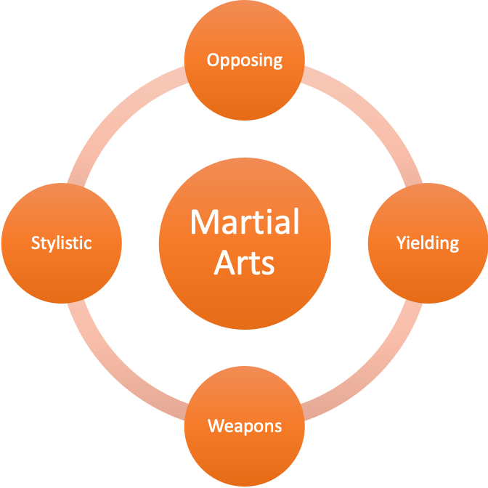

Karate, Kung Fu

Judo,

Ju Jitsu

Kubudo, Kendo

Tai Ch’i

Capoeira

Fig 1: An approach to understanding the movement qualities of martial arts

Students learn several moves from each categorisation in order to embody these qualities for themselves. The emphasis here is to infuse themselves the stylistic quality rather than perform the moves “correctly” in a combat situation. Many of these elements are taught in partnership as well as individually in a “kata” form to allow for a deeper understanding.

Once students have a movement sense of the four categories, we can begin to frame the conversations (fig 2). Contemporary dance styles are identified that share movement or philosophical characteristics. These are styles that the students have studied earlier and so have a pre-existing embodiment of their movement qualities. Students help identify qualities that these styles share and how these conversations can be initiated.



Figure 2: Framing the conversation

Routines are created that bring out these qualities and can form a natural point of exploration. These exercises are shown below.

VIDEOS with stylistic qualities beneath.

Following this exploration of martial arts, we then look at a similar approach using urban styles. The similarities between urban styles and some forms of martial arts and explored and this helps the students frame their own conversations between contemporary and urban styles. The use of martial arts effectively acting as a halfway point to allowing students to creating their own integrative practices between two styles that might appear quite disparate.

**Conclusion**

By learning these exercises students are developing an understanding of the qualities of martial arts through their own movement style, rather than as a stand-alone subject. This approach helps develop a deeper soma-empathic understanding without de-prioritising their own movement histories. It introduces the students to the idea of communication and understanding through a particular (todo lens) but it also makes this lens explicit. Students are thus introduced to the idea that their understanding of other cultures is fundamentally biased by their own cultural backgrounds and experiences.

Through the process we also hope to cultivate a wider curiosity about the process of working with different movement styles outside traditional “dance”. Students have, of their own choice, developed their own conversations between contemporary dance and hula, pole, Japanese fan dance, yoga and aerial hoop. It is our belief that these kinds of conversations help develop a more nuanced understanding of culture and integration within society more widely.