Atmospheric Transport Reveals Grass Pollen Dispersion Distances
Carl A. Frisk^{ab*}, Godfrey P. Apangu^{ac}, Geoffrey M. Petchª, Beverley Adams-Groomª & Carsten A. Skjøthª
ª National Pollen and Aerobiological Research Unit, School of Science and the Environment, University of Worcester, Henwick Grove, WR2 6AJ, Worcester, UK.
^{b} Current Address: School of Biology and Environmental Sciences, University College Dublin, Belfield, Dublin 4, Ireland
^{c} Current Address: Department of Biointeractions & Crop Protection, Rothamsted Research, West Common, AL5 2JQ, Harpenden, UK.
* Corresponding author. Email: carl.frisk@ucd.ie

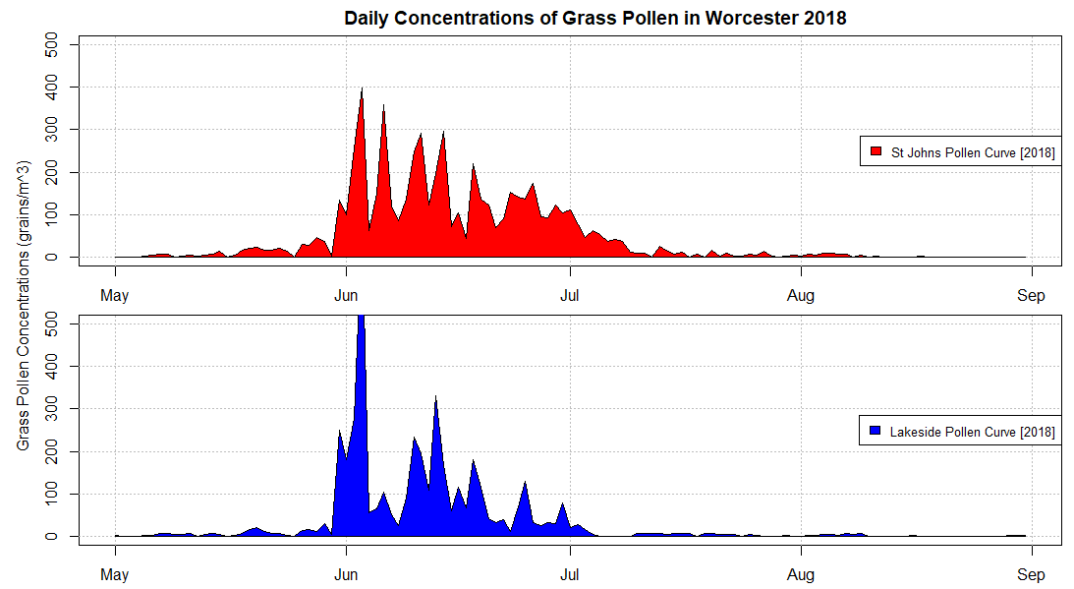
Supplementary Figure 1. Daily concentrations of grass pollen from two locations (St Johns and Lakeside) during the 2018 season in Worcester.
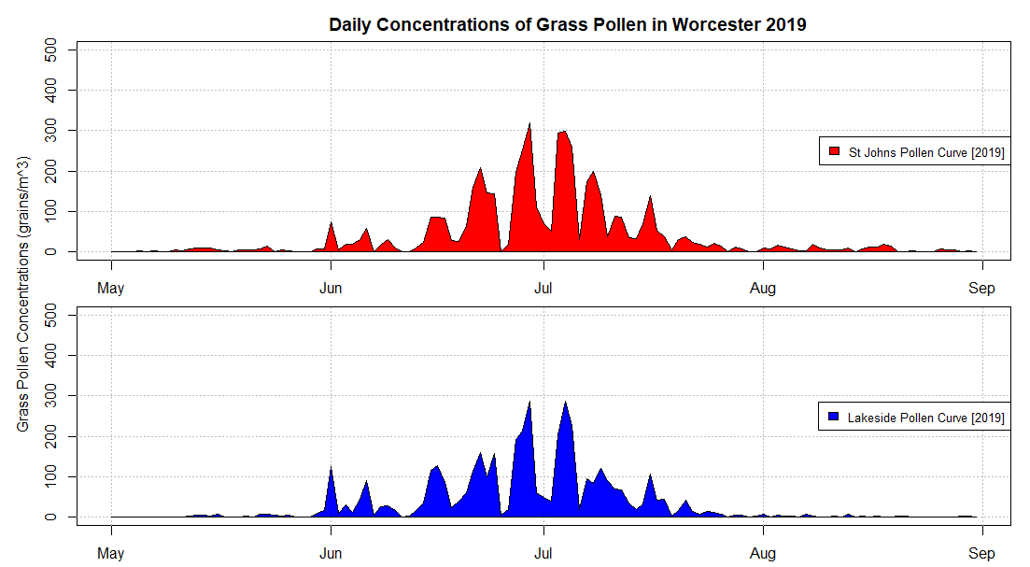
Supplementary Figure 2. Daily concentrations of grass pollen from two locations (St Johns and Lakeside) during the 2019 season in Worcester.
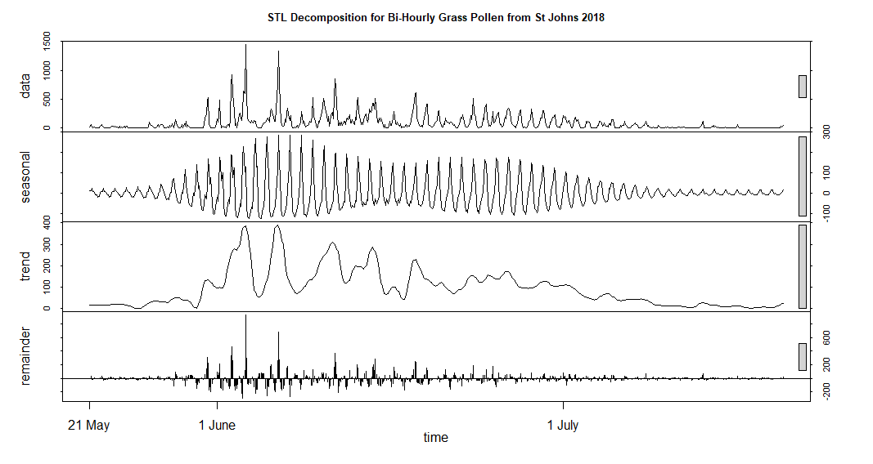
Supplementary Figure 3. STL Decomposition for the 95% overlapping period of bi-hourly grass pollen concentrations for St Johns during the 2018 season in Worcester. The x-axis reflects the duration of the 95% overlapping period, which varies between years.
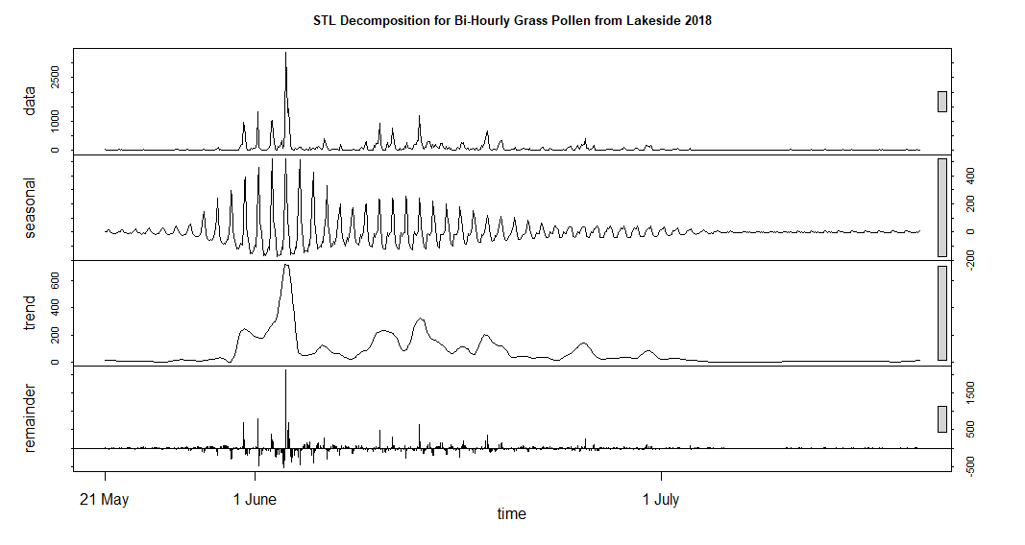
Supplementary Figure 4. STL Decomposition for the 95% overlapping period of bi-hourly grass pollen concentrations for Lakeside during the 2018 season in Worcester. The x-axis reflects the duration of the 95% overlapping period, which varies between years.
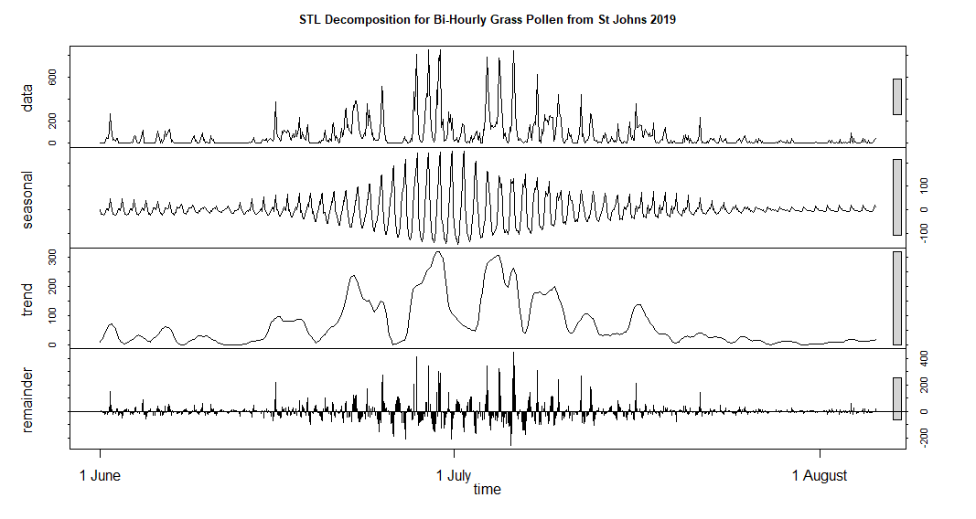
Supplementary Figure 5. STL Decomposition for the 95% overlapping period of bi-hourly grass pollen concentrations for St Johns during the 2019 season in Worcester. The x-axis reflects the duration of the 95% overlapping period, which varies between years.
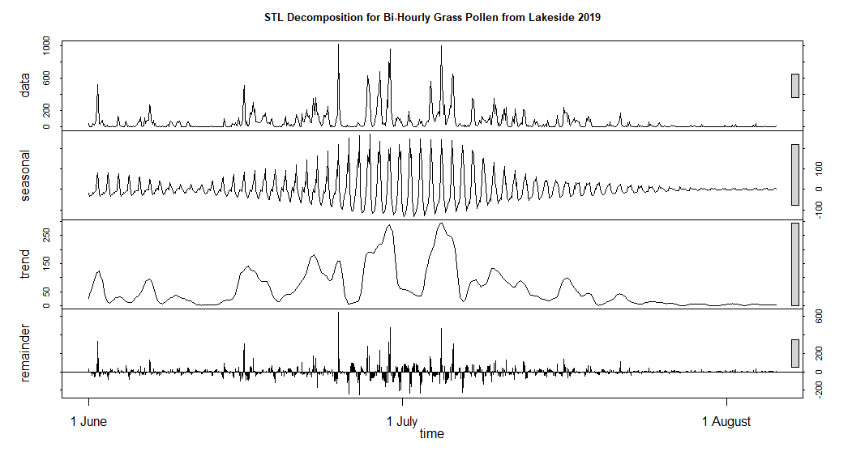
Supplementary Figure 6. STL Decomposition for the 95% overlapping period of bi-hourly grass pollen concentrations for Lakeside during the 2019 season in Worcester. The x-axis reflects the duration of the 95% overlapping period, which varies between years.
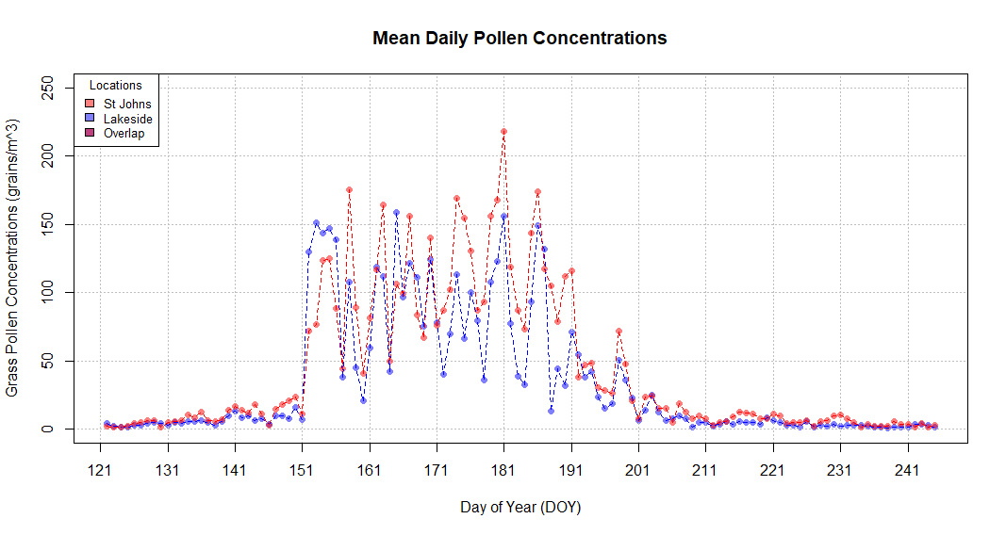
Supplementary Figure 7. Comparison of mean daily grass pollen concentrations for St Johns and Lakeside, averaged between all bi-hourly and years values.
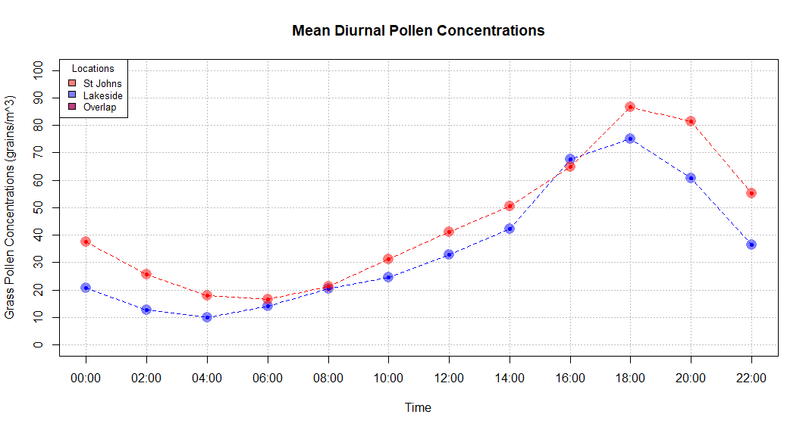
Supplementary Figure 8. Comparison of mean diurnal grass pollen concentrations for St Johns and Lakeside, averaged between all daily and yearly values.
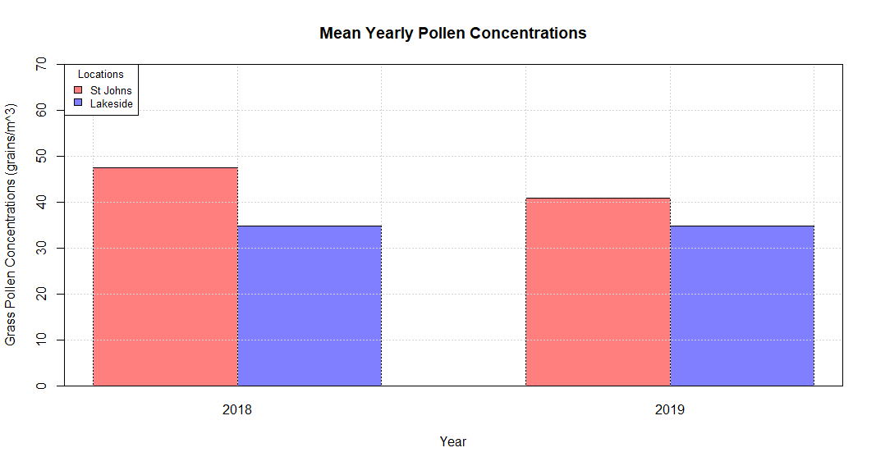
Supplementary Figure 9. Comparison of mean year grass pollen concentrations for St Johns and Lakeside, averaged between all bi-hourly and daily values.

